**A CRM APPLICATION FOR LAPTOP RENTALS**

By

Gogurla Manoj

gogurlamanoj@gmail.com

User Name: gogurlamanojproject@694.mru

**PROJECT ABSTRACT**

The Salesforce-based A CRM APPLICATION FOR LAPTOP RENTALS   application on  Laptop rentals is about delivering the items to the customers by rental purpose. It leverages the power of customer relationship management (CRM) to enhance customer experiences, optimize store operations, and improve overall efficiency. Additionally to these, we also need to do an effective CRM i.e via communicating through email with the potential customers identified.

**INTRODUCTION**

 The entire laptop rental process, from managing client connections to streamlining operations, is intended to be streamlined and improved by the Salesforce-based CRM Application for Laptop Rentals. This application concentrates on providing a seamless customer experience by utilizing the powerful features of Salesforce CRM. It guarantees timely delivery of rental laptops and effective service management.

**INDEX PAGE**

|  |  |
| --- | --- |
| TOPICS | PAGE NO |
| Task 1 | 5 |
| Task 2 | 5-8 |
| Task 3 | 8-11 |
| Task 4 | 11-12 |
| Task 5 | 12-20 |
| Task 6 | 20-23 |
| Task 7 | 23-25 |
| Task 8 | 25-27 |
| Task 9 | 27-29 |
| Task 10 | 29-31 |
| Task 11 | 31-32 |
| Task 12 | 32-33 |

**TASK 1**

**1.1 Creating the Developer Account**

1)To create a developer account in Salesforce, follow these steps:

2)Go to Salesforce Developer Signup.

* Fill in the signup form with the following details:
* First name & Last name
* Email
* Role: Developer
* Company: Malla Reddy University
* Country: India
* Postal Code: Pin code
* Username: gogurlamanojproject@694.mru

3)Click Sign me up.

**1.2 Activating the Account**

* Check the inbox of the email you used for signup.
* Click on the verification link to activate your account (the email may take 5-10 minutes to arrive).
* Click on **Verify Account**.
* Set a password and answer a security question.
* Click on **Change Password**.
* You will be redirected to your Salesforce setup page.

**TASK 2**

**Creating the Custom Objects:**

This report outlines the steps to create various custom objects in Salesforce, specifically for a Garage Management System. The objects include consumer, Billing Process, Laptop Bookings, and Total Laptops. These objects will help streamline operations and improve data management within the system.

**2.1 Total Laptops Object**

* Navigation Path: From the setup page, click on Object Manager >> Create >> Custom Object.
* Details:

Label Name:  Total Laptops

Plural Label Name: Total Laptops

Record Name: Total Laptops

Data Type: Text

Options: Allow reports, Track Field History, Allow search

* Save: Click Save to create the object.

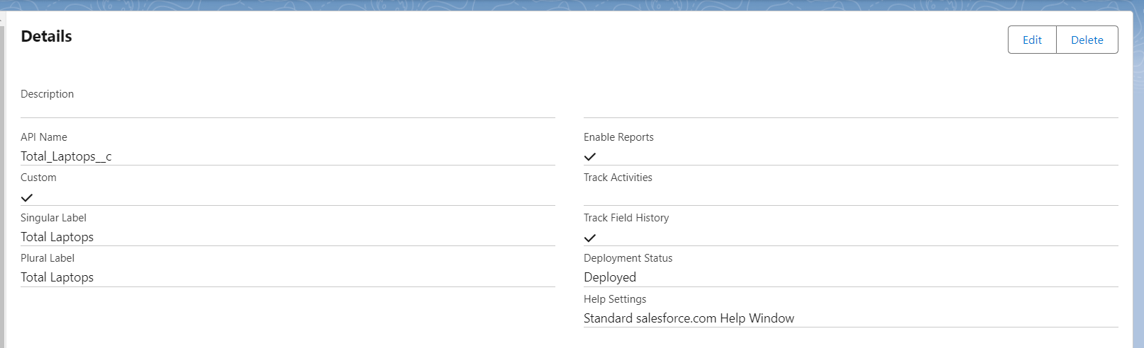

**2.2 consumer Object**

* Navigation Path: From the setup page, click on Object Manager >> Create >> Custom Object.
* Details:

Label Name: consumer

Plural Label Name: consumer

Record Name: consumer_name

Data Type: Name

Options: Allow reports, Track Field History, Allow search

* Save: Click Save to create the object.

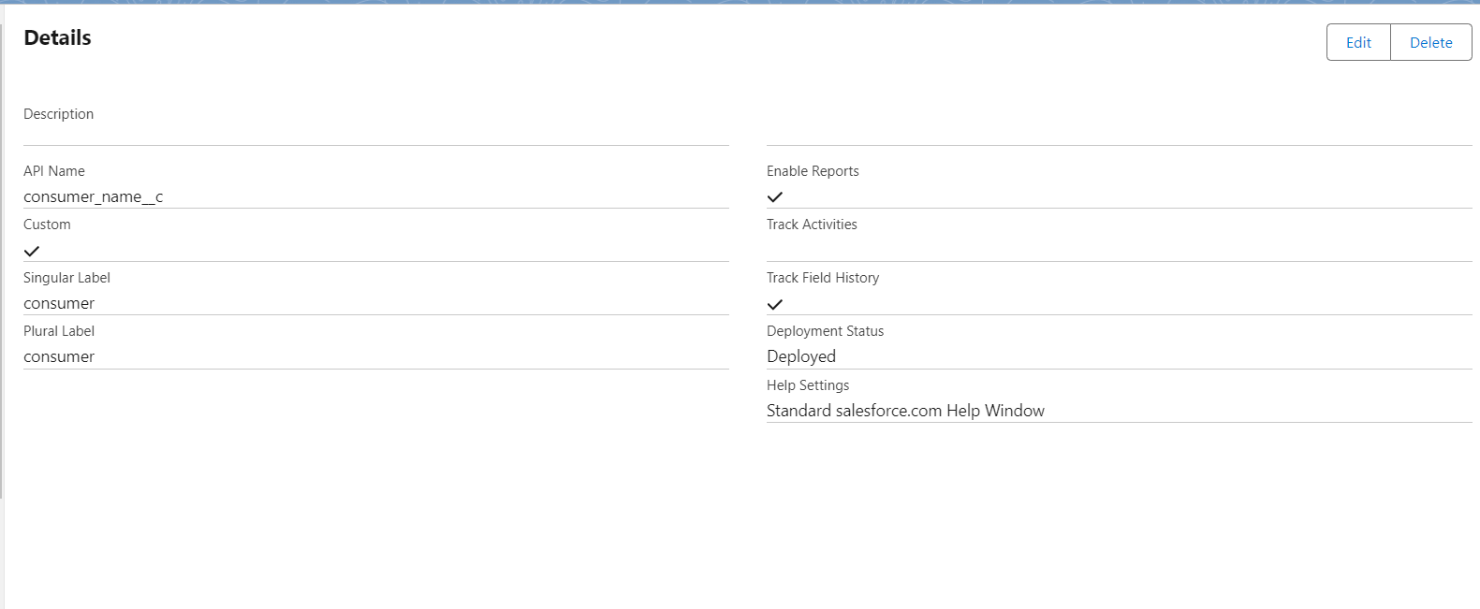

**2.3 Laptop Bookings Object**

* Navigation Path: From the setup page, click on Object Manager >> Create >> Custom Object.
* Details:

Label Name: Laptop Bookings

Plural Label Name: Laptop Bookings

Record Name: Laptop Bookings

Data Type: Name

Options: Allow reports, Track Field History, Allow search

* Save: Click Save to create the object.

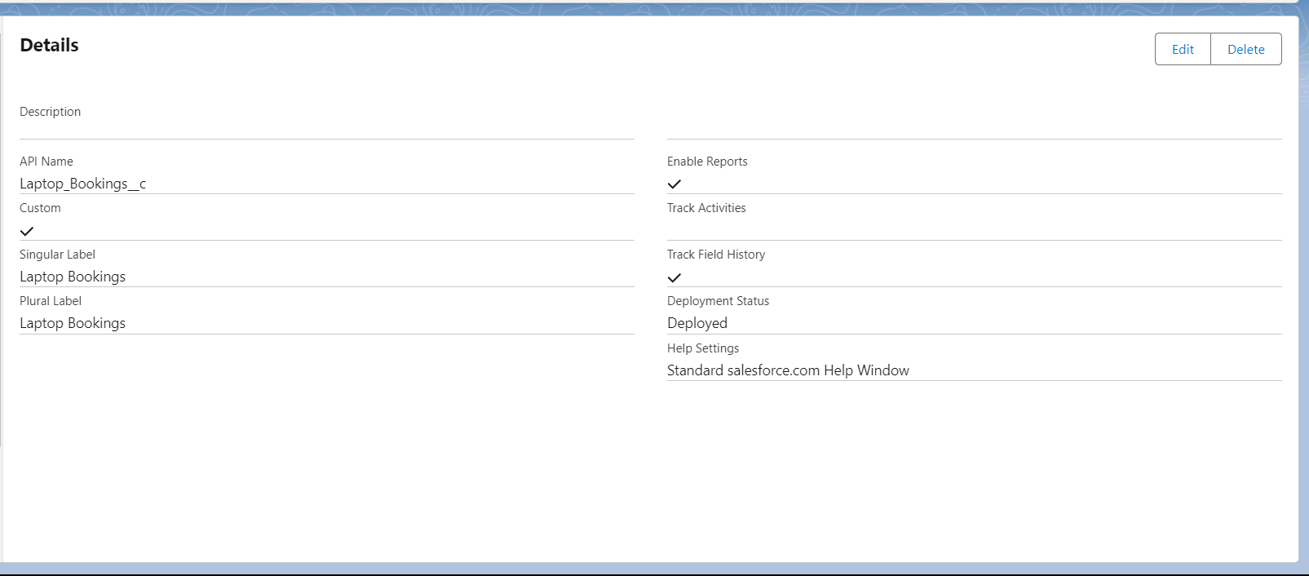

**2.4 Billing Process Object**

* Navigation Path: From the setup page, click on Object Manager >> Create >> Custom Object.
* Details:

Label Name: Billing Process

Plural Label Name: Billing Process

Record Name: Billing ProcessName

Data Type: Name

Options: Allow reports, Track Field History, Allow search

* Save: Click Save to create the object.

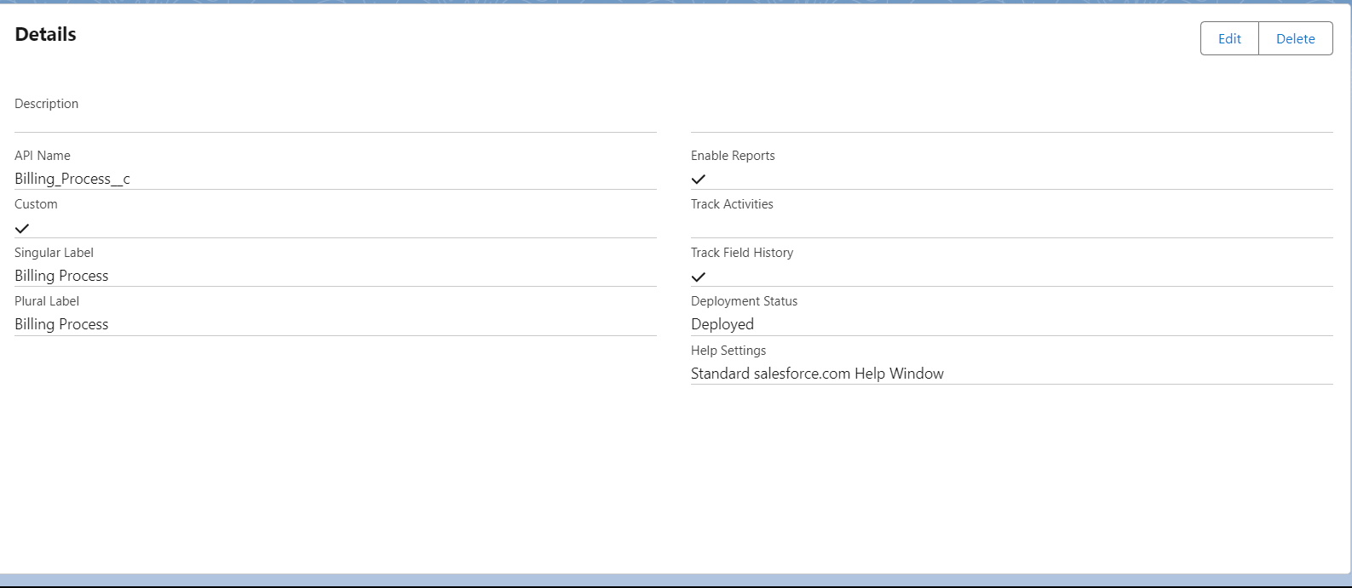

**TASK 3**

**3.1 Creating a Custom Tab**

* Creating a Custom Tab for Customer Details
* Navigation Path:

Go to the setup page.

Type "Tabs" in the Quick Find bar.

Click on "Tabs".

Click on "New" under the Custom Object Tabs.

* Details:

Select Object: consumer

Select Tab Style: Choose a style that represents consumer.

* Click Next.
* Add to Profiles Page: Keep the default settings.
* Click Next.
* Add to Custom App: Uncheck "Include Tab".
* Ensure "Append tab to users' existing personal customizations" is checked.
* Click Save.

**3.2 Creating Remaining Tabs (Laptop Bookings, Total Laptops, Billing process)**

* Repeat the above steps for each remaining object: Appointments, Service Records, and Billing Details and Feedback.
* Navigation Path:

Go to the setup page.

Type "Tabs" in the Quick Find bar.

Click on "Tabs".

Click on "New" under the Custom Object Tabs.

* Details for Each Object:

Select Object: Choose the respective object (Laptop Bookings, Billing Process, Total Laptops).

Select Tab Style: Choose a suitable style for each object.

* Click Next.
* Add to Profiles Page: Keep the default settings.
* Click Next.
* Add to Custom App: Uncheck "Include Tab".
* Ensure "Append tab to users' existing personal customizations" is checked.
* Click Save.

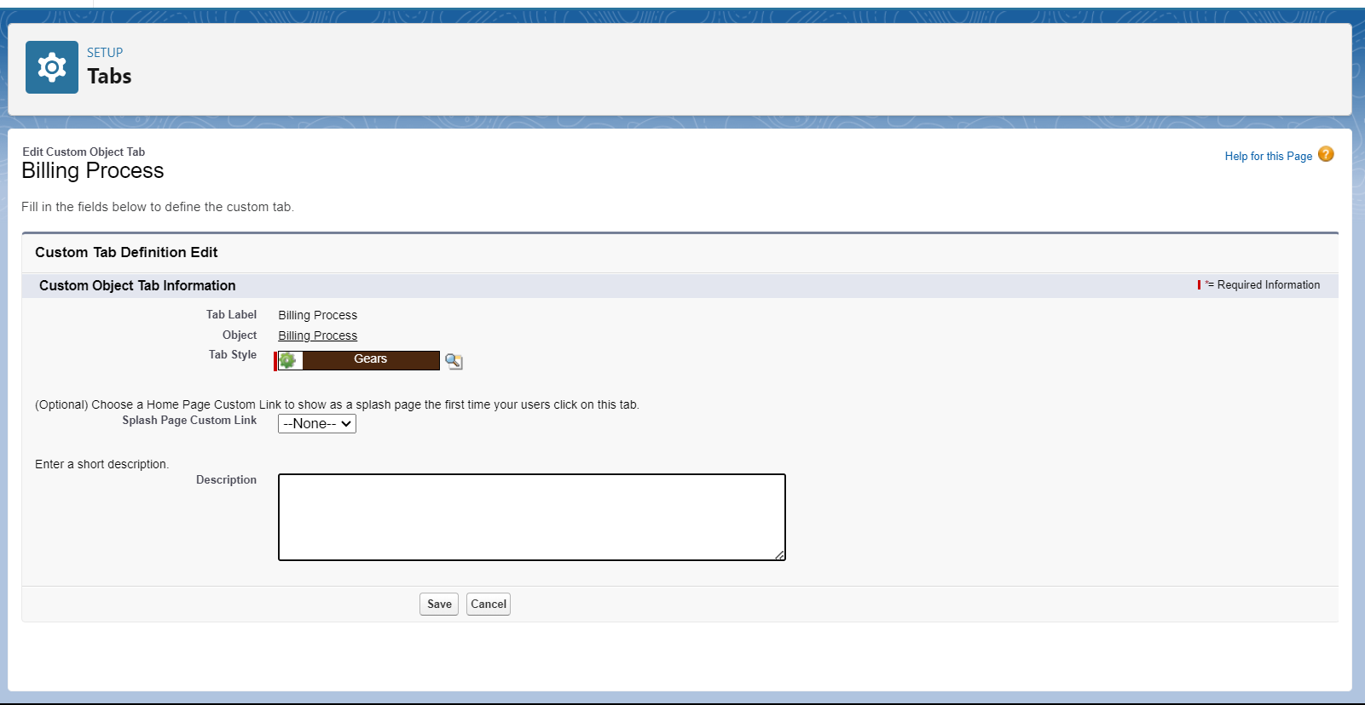

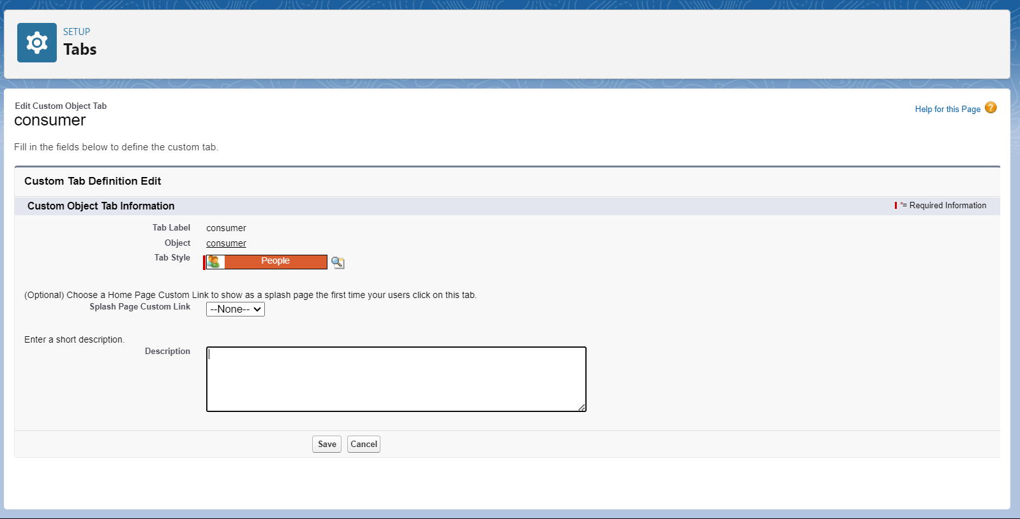

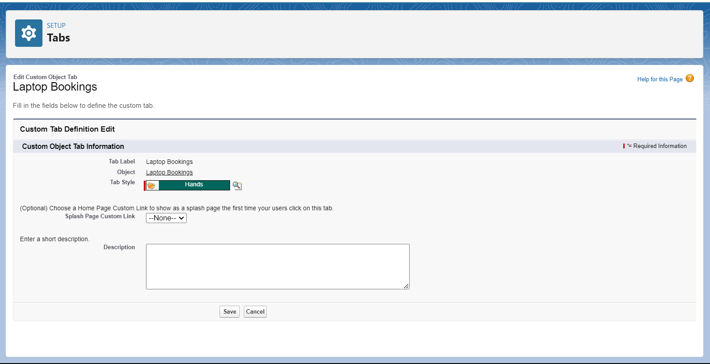

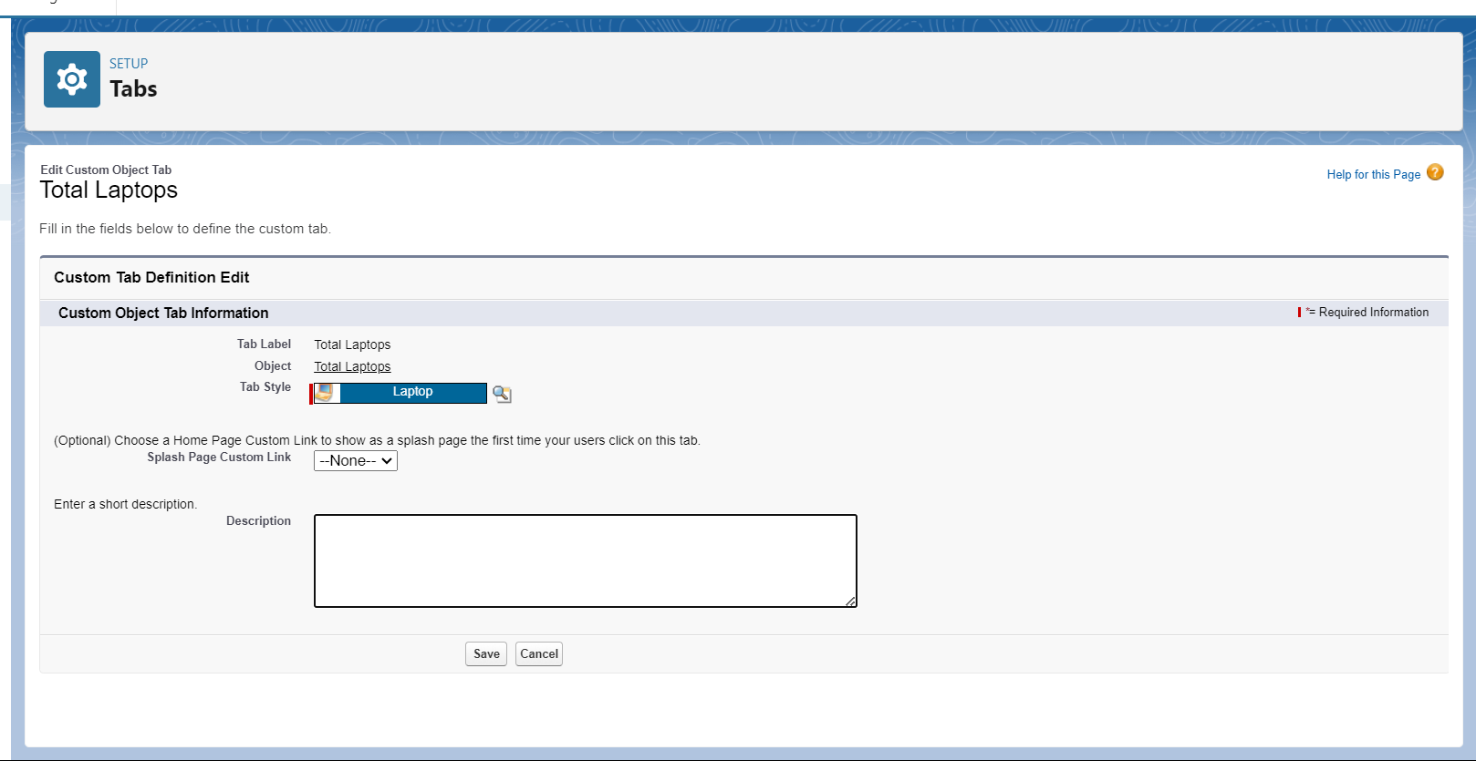

**Task 4**

**Building Lighting App**

For the purpose of managing laptop rental operations, a Lightning App in Salesforce can be created that streamlines procedures and effectively manages several business aspects. The procedures to establish the CRM for Laptop Rental are described in this guide, along with how to add user profiles and other navigation items.

**4.1 Creating a Lightning App**

Steps to Create a Lightning App

* Accessing App Manager:

Begin by navigating to the setup page. In the Quick Find bar, search for "App Manager" and select it. Click on "New Lightning App" to start the creation process.

* App Details:

Enter the name "Laptop Rentals" in the app details. Proceed to the next steps, keeping all settings on the App Options and Utility Items pages as default.

* Adding Navigation Items:

To enhance navigation within the app, select essential items such as consumer, Laptop Booking, Total Laptops, Billing Process, Reports, and Dashboards from the search bar. Move these items using the arrow button to include them in the app’s navigation menu.

* Assigning User Profiles:

To ensure appropriate access and functionality, search for the "System Administrator" profile in the search bar. Add this profile by clicking the ar button. Complete the setup by saving and finishing the configuration.

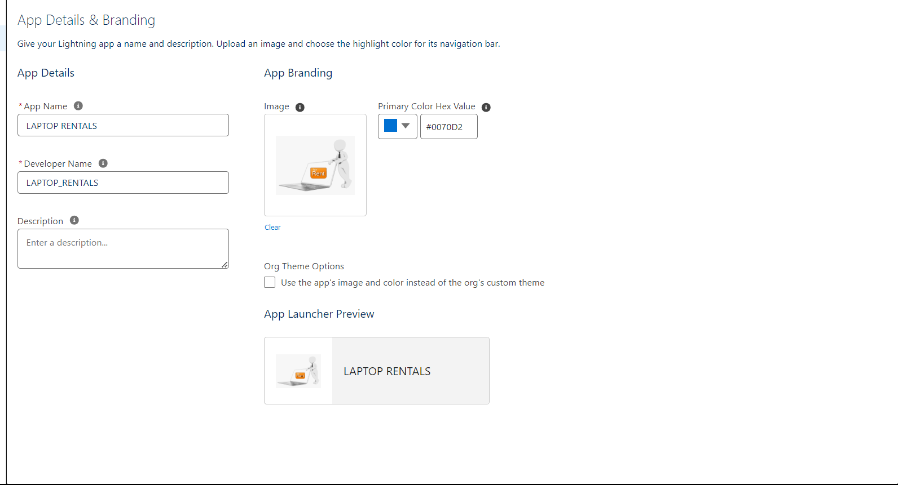

**Task 5**

**Creating Fields**

**5.1 consumer Details Object Fields**

* Phone Field:

Created a phone field labelled "Phone Number" to store consumer contact numbers.

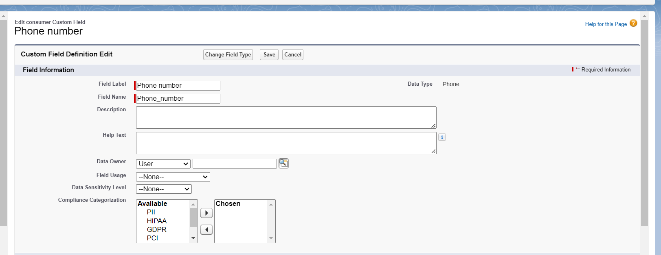

* Email Field:

Added an email field labelled "Email" to capture consumer email addresses.

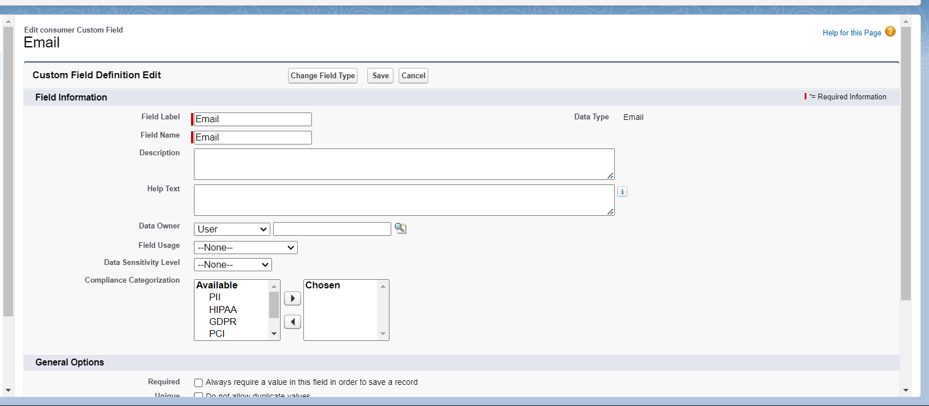

* Address Field:

Added a text area field labelled "Address" to capture consumer addresses.

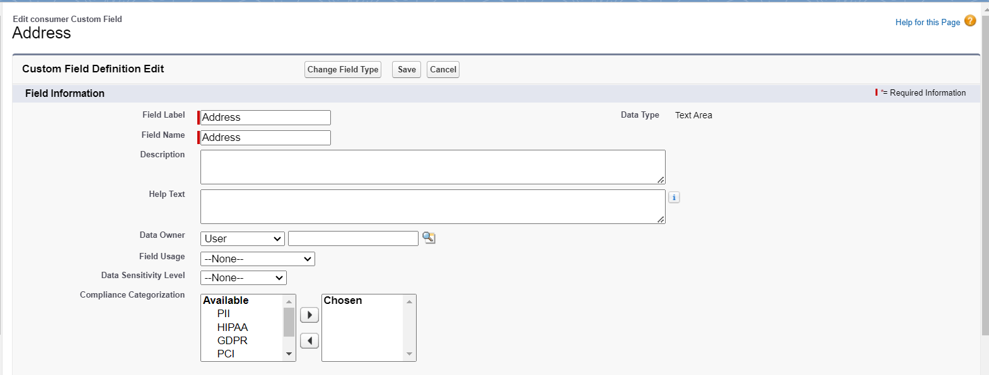

**5.2 Lookup Fields**

* Laptop Booking Object:

Established a lookup relationship field labelled ‘Name’ to link Laptop Bookings to consumer, ensuring Laptop Bookings are associated with the correct consumer.

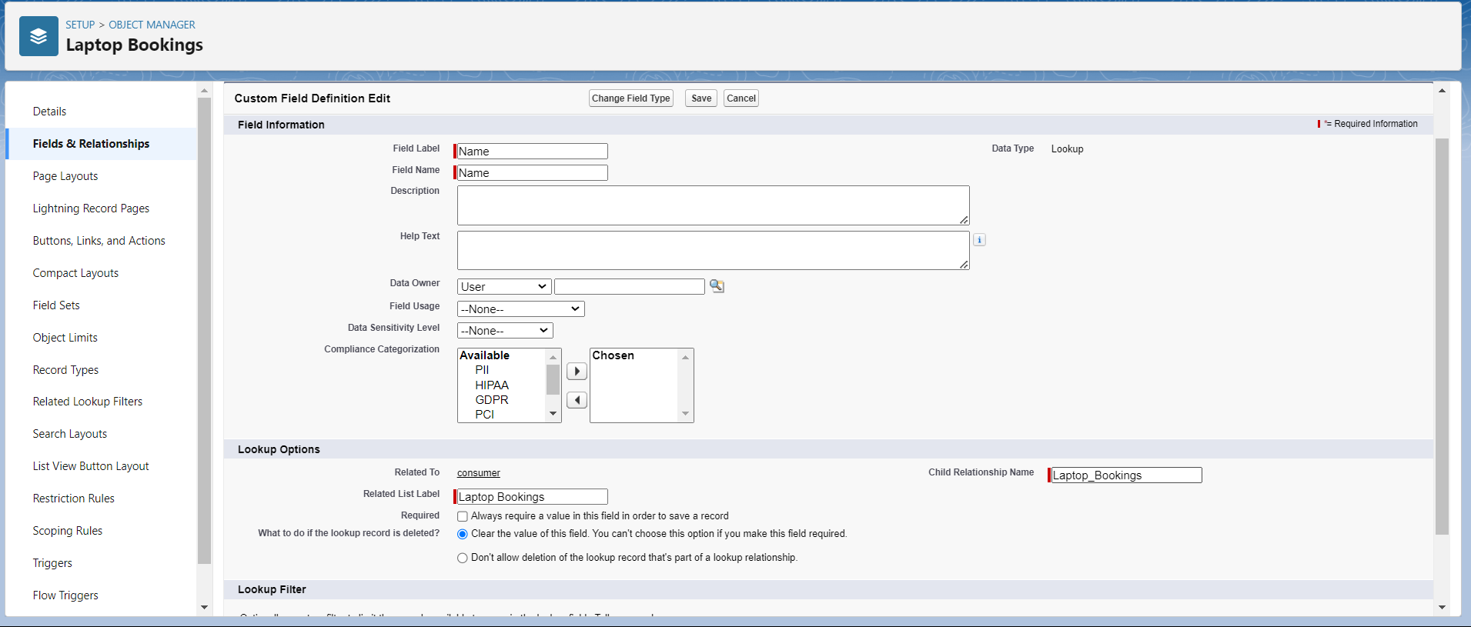

* Laptop Booking Object:

Established a lookup relationship field to link Laptop Bookings to Total Laptops, ensuring Laptop Bookings are associated with the correct Total Laptops. Later updated this lookup to master-detail relationship and created a Roll-up summary with COUNT

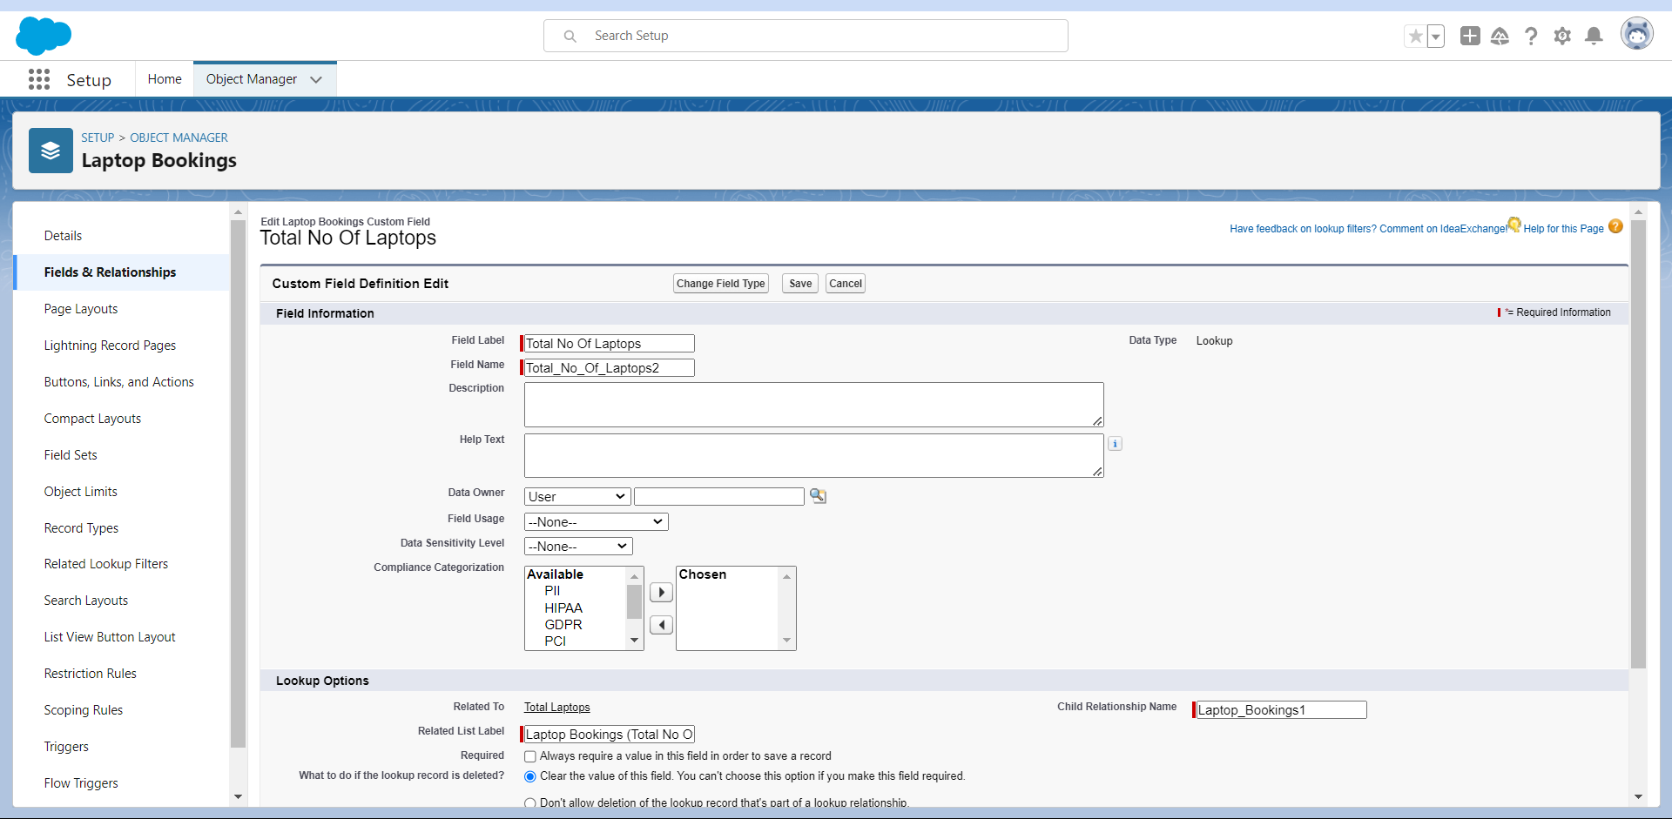

* Billing Process Object:

Created a lookup relationship field to link Billing Process records to Laptop Bookings. The label is “Laptop Booking.”

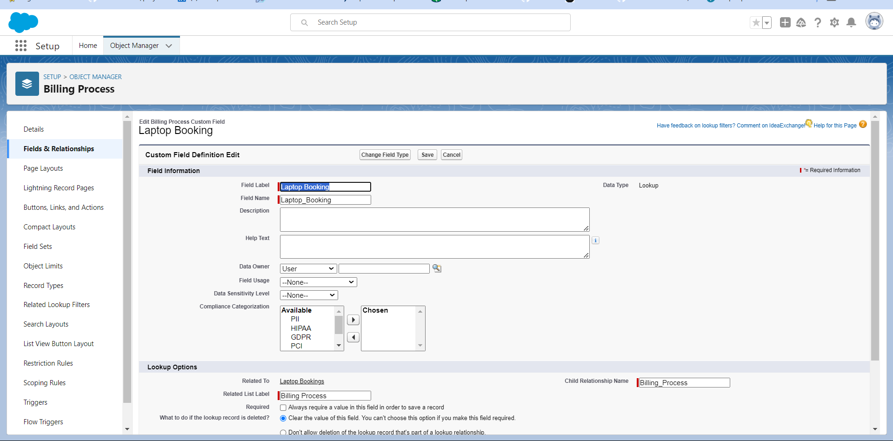

**5.5 Master-Detail Relationship Field**

* Billing Process Object:

Added a master-detail field labelled " Name" with consumer object to ensure the relationship between consumer and Billing Process objects.

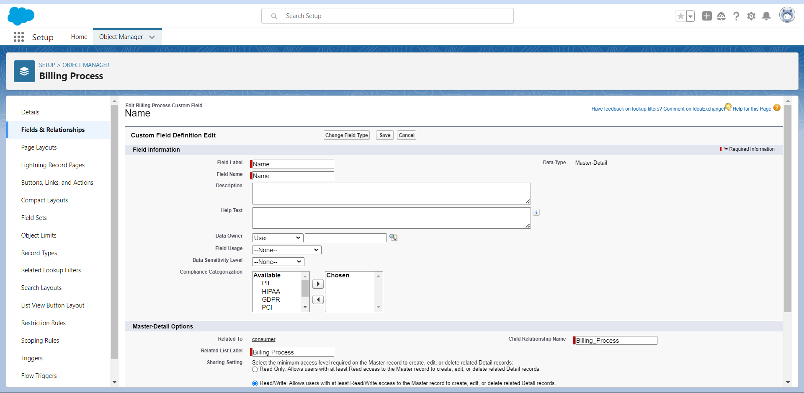

**5.6 Currency Fields**

* Laptop Booking Object:

Created a currency field labelled " Amount" to record the cost of services provided.

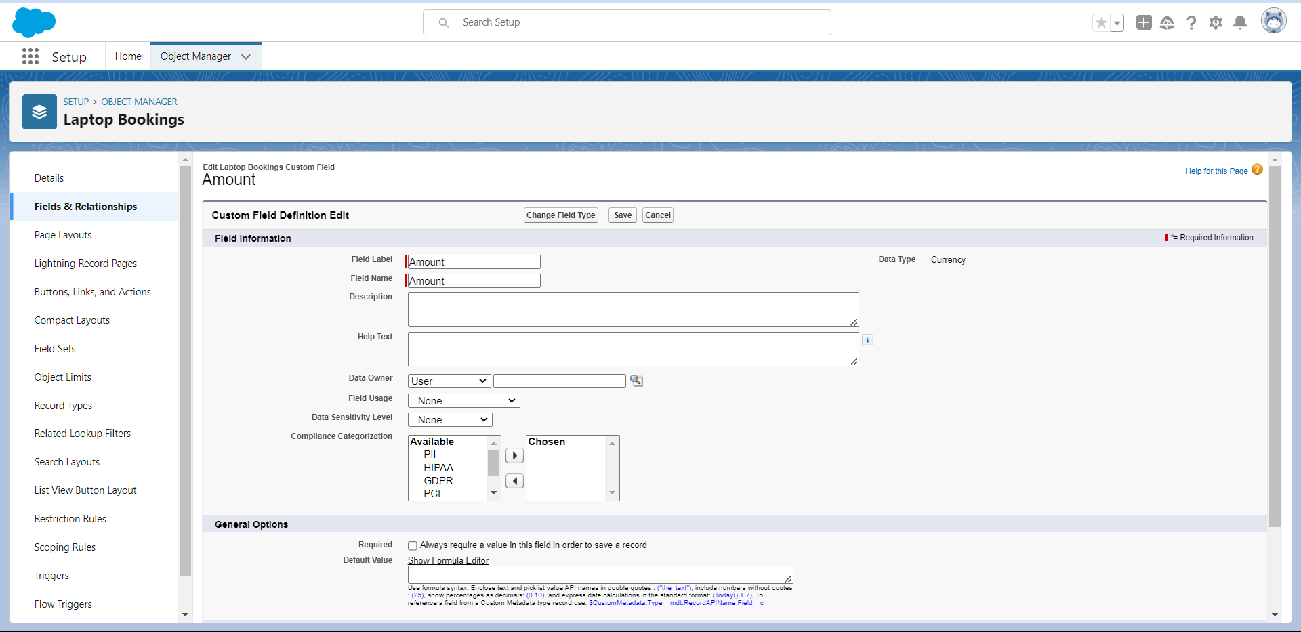

**5.8 Picklist Fields**

* consumer Object:

Created a picklist field labelled "consumer Status" with values "Student" and "Employee" and "Others" to know the consumer status.

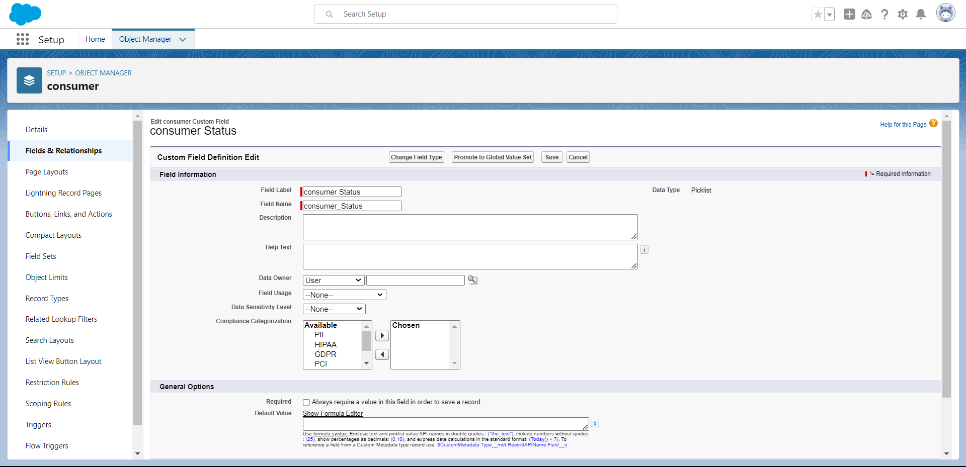

* Laptops Booking Object:

Created a picklist field labelled " Laptop Brand" with values "Dell", "Acer", "Hp" and "Mac" to let the consumer select the laptop brand.

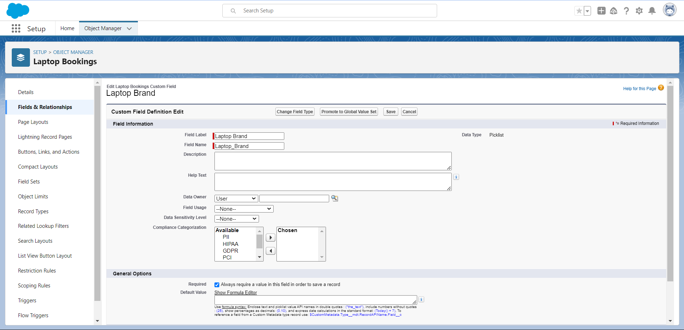

* Laptops Booking Object:

Created a picklist field labelled " processer" with values "i3", "i5", "i7" and "Biochip" to let the consumer select the processor.

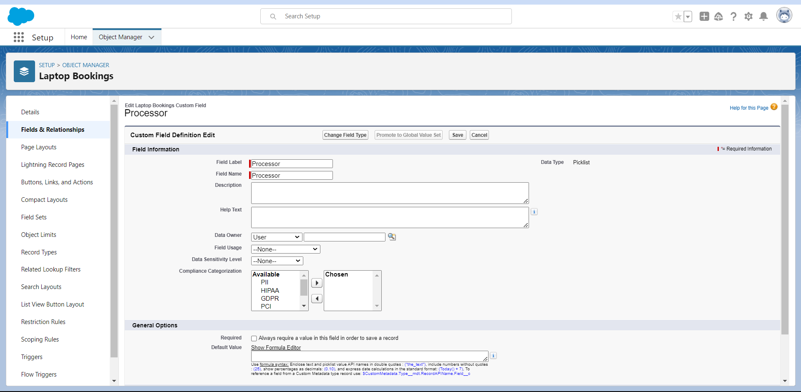

* Laptops Booking Object:

Created a picklist field labelled " No.of laptops" with values 1,2,3,4,5 a to let the consumer select number of laptops for booking.

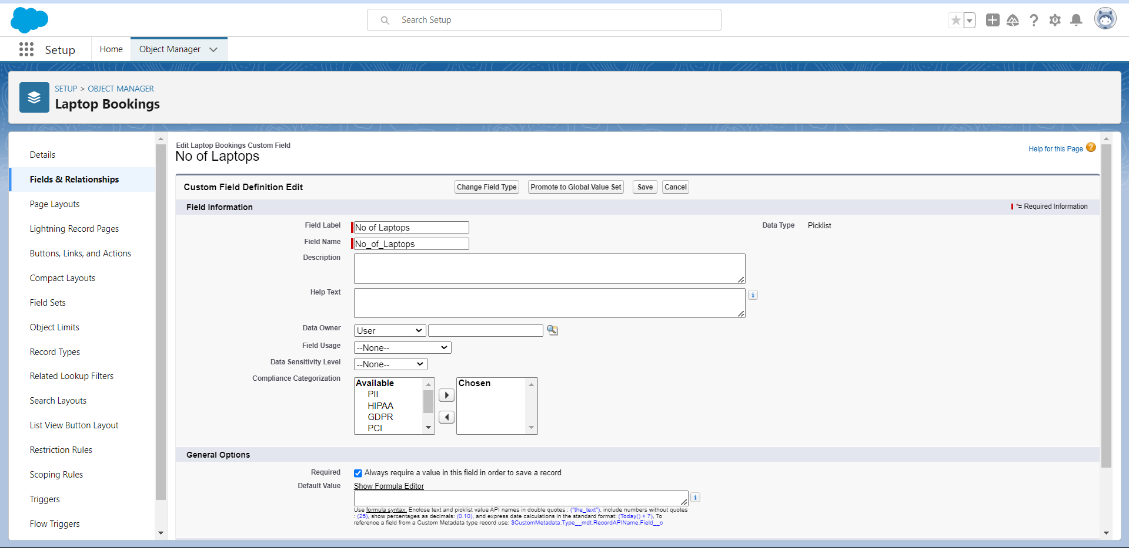

* Billing Process Object:

Created a picklist field labelled " Payment Mode" with values Cash, Check and many to let the consumer select convenient payment method.

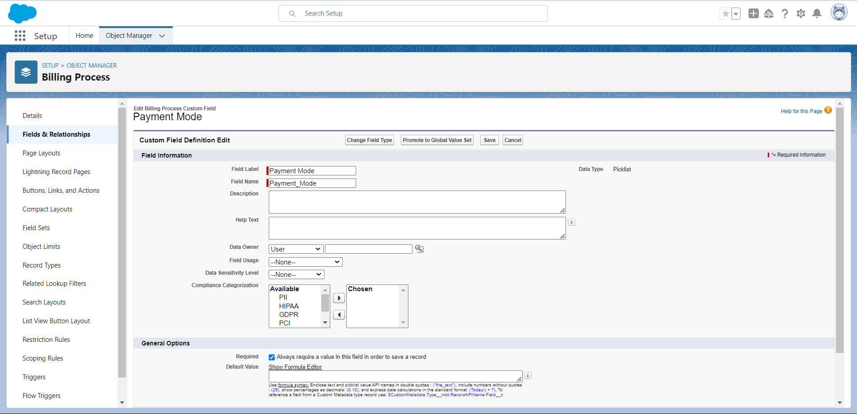

**5.9 Formula Fields**

* Laptop Booking Object:

Created a formula field labelled "Laptops Available" to automatically update the laptops remaining/available. As an example taken 50 laptops with the formula

“50 - Total_no_of_laptops__r.Laptops_delivered__c ”

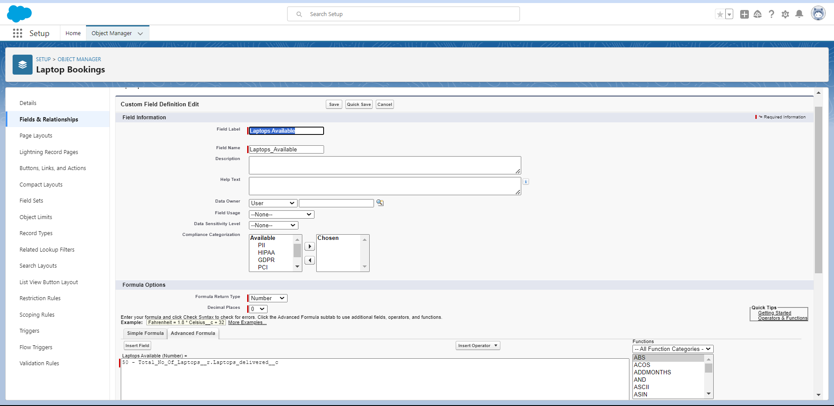

* Billing Process Object:

Created a formula field labelled "Amount" to automatically calculate the amount to be paid by the customer for the laptops. Return type is Number.

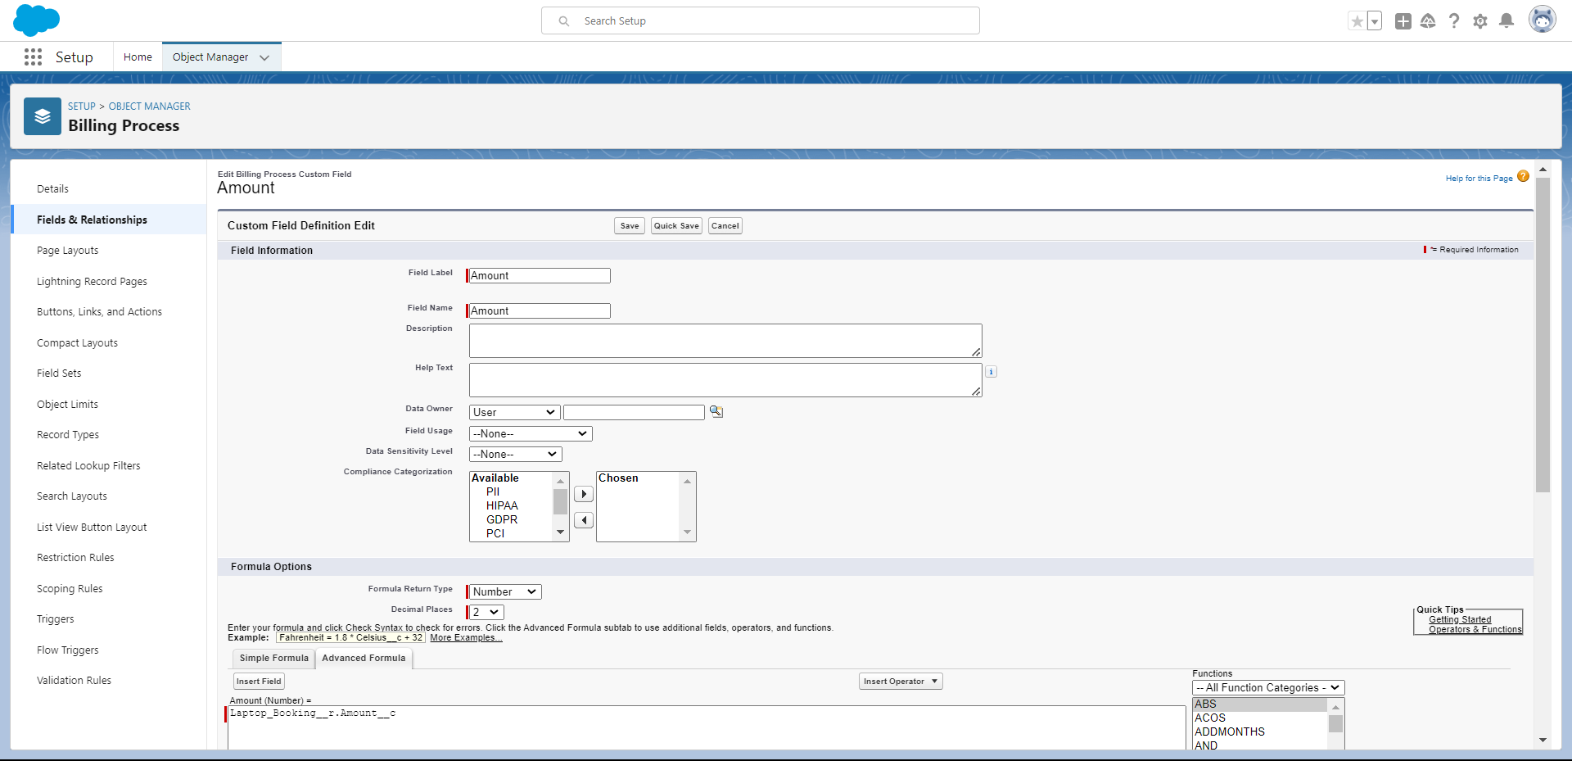

* Total Laptops Object:

Created a formula field labelled " Laptops Available" to automatically calculate the amount to be paid by the customer for the laptops. Return type is Number.

50 - Total_no_of_laptops__r.Laptops_delivered__c

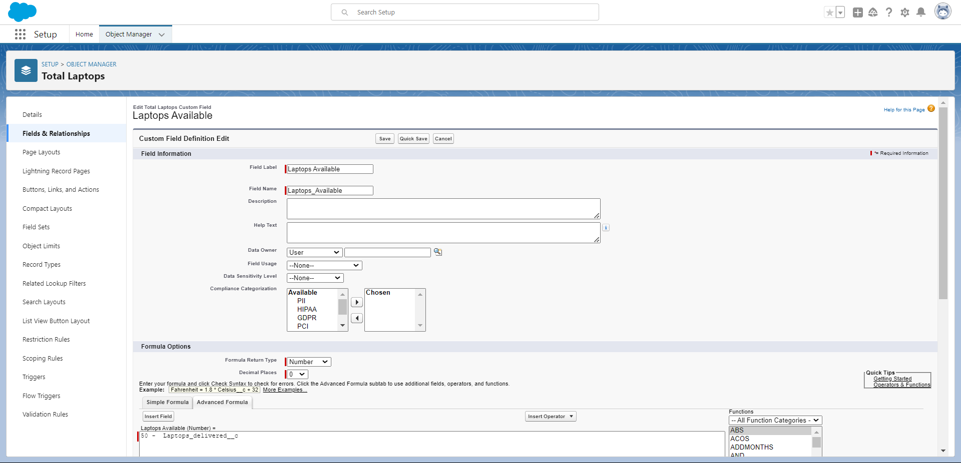

**Task 6**

**Validation Rules**

**6.1 Validation Rule for Appointment Object**

* Rule Name: Phonenumberoremailblankrule
* Purpose: Ensure that the phone number and email of consumer are not blank.
* Formula:

**(OR( ISBLANK( phone_number__c ) , ISBLANK( email__c ) )**

* Error Message: "Please enter a valid number"
* Error Location: Field – phone number or email.

**Task 8**

**Profiles**

**8.1 Creating the Manager Profile**

1. **Profile Cloning**:
   * Clone the Standard User profile to create a new profile named "Owner."
2. **Custom Object Permissions**:
   * Grant access permissions for the following objects:
     + consumer
     + Billing Process
     + Laptop Booking
     + Total Laptops

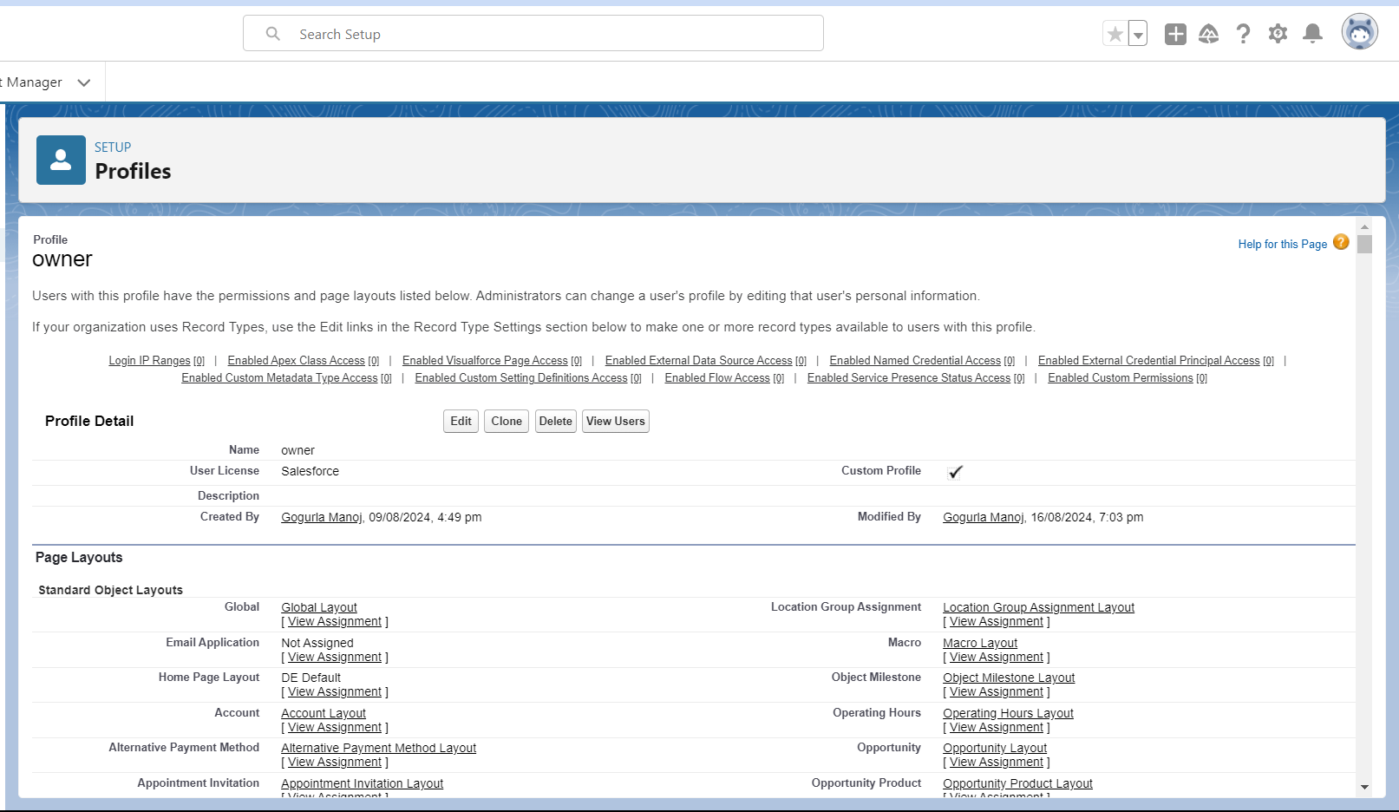

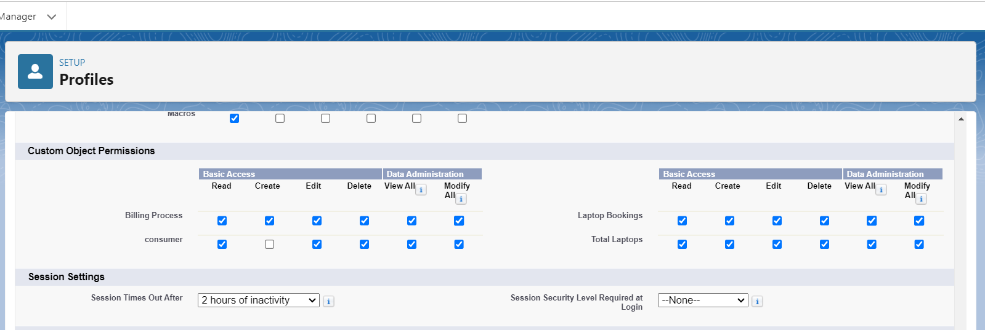

**8.2 Creating the Agent Profile**

1. **Profile Cloning**:
   * Clone the Salesforce Platform User profile to create a new profile named "Agent."

**Custom Object Permissions**:

* + Grant access permissions for the following objects:
    - consumer
    - Billing Process
    - Laptop Booking
    - Total Laptops

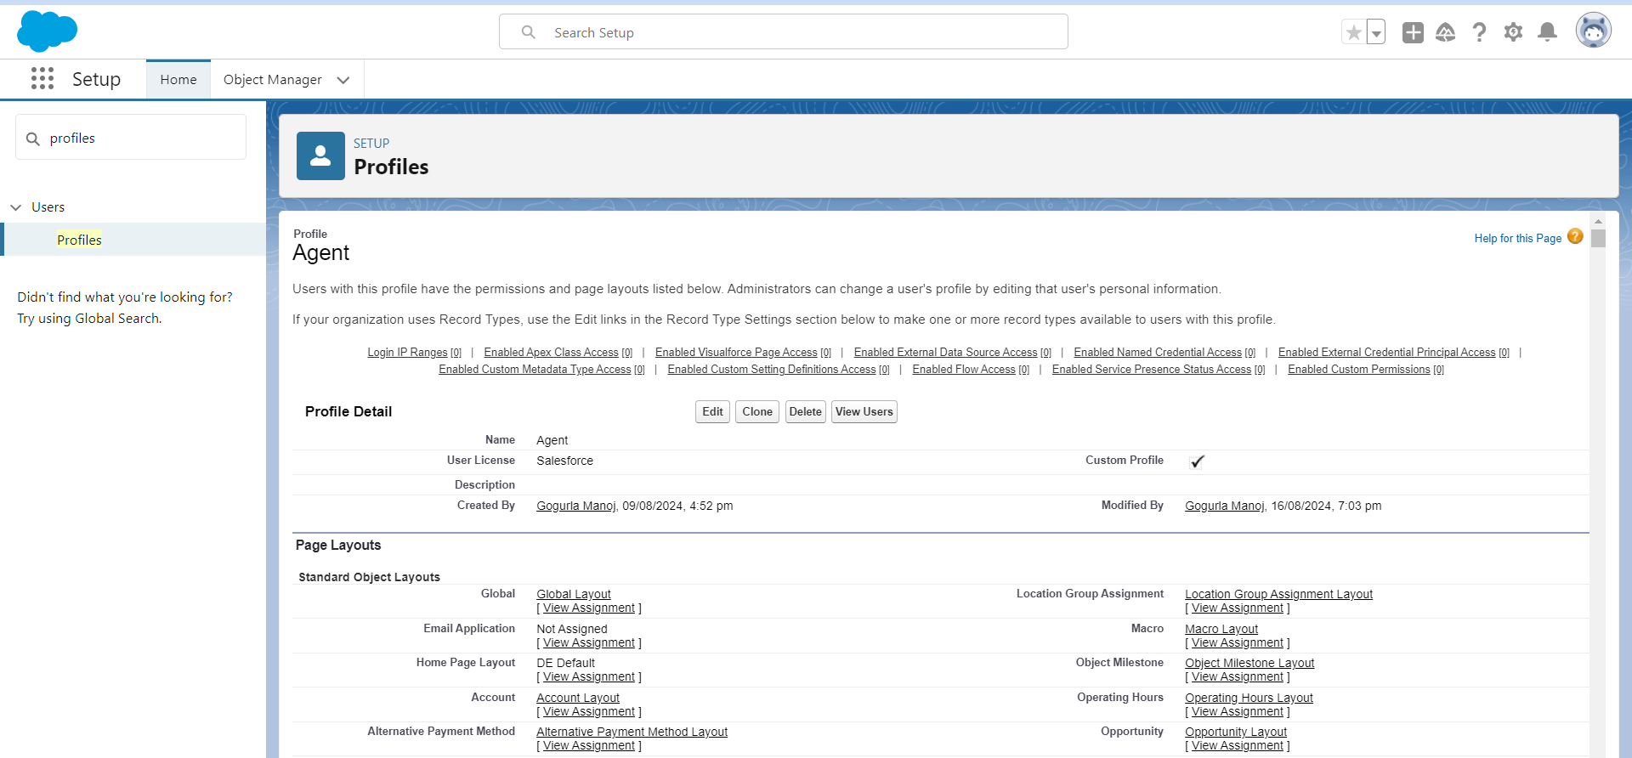

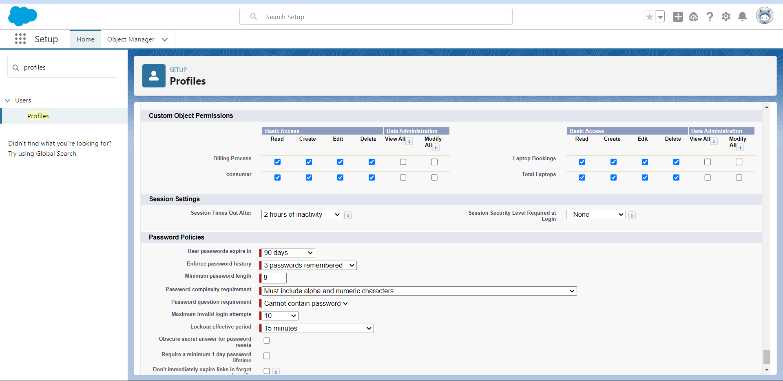

**Task 9**

**Role And Role Hierarch**

**9.1 Creating the Owner Role**

1. **Access Roles Setup**:
   * Navigate to the roles setup section in Salesforce.
2. **Expand Role Hierarchy**:
   * Expand all roles and add a new role under the appropriate superior role.
3. **Define Role Details**:
   * Label the new role as "Owner" and save the configuration.

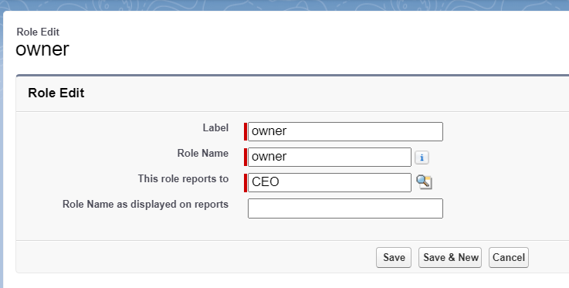

**9.2 Creating Sales Person Role**

1. **Access Roles Setup**:
   * Navigate to the roles setup section in Salesforce.
2. **Add Role Under Manager**:
   * Expand the CEO role and add a new role under the owner role.
3. **Define Role Details**:
   * Label the new role as "Agent" and save the configuration.

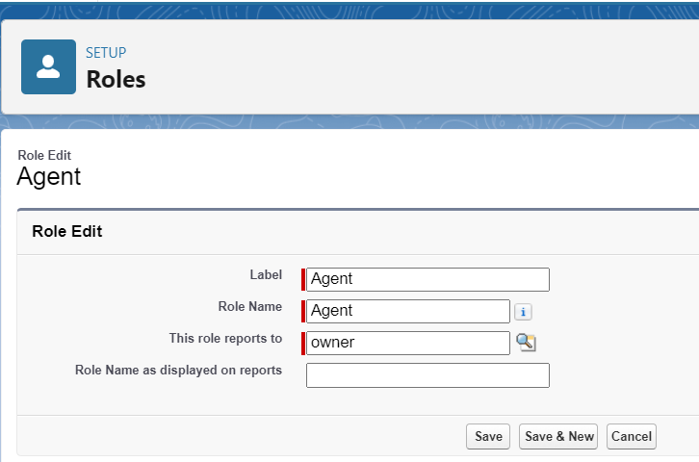

**Task 10**

**Users**

**10.1 Creating a Owner User**

1. **Access User Setup**:
   * Navigate to the users section in Salesforce setup.
2. **New User Details**:
   * Fill in the required fields with the user's details, such as first name, last name, alias, email, username, and nickname.
   * Assign the role of "owner."
   * Set the user license to "Salesforce."
   * Assign the profile of "owner."
3. **Save the Configuration**:
   * Save the user details to create the new owner user.

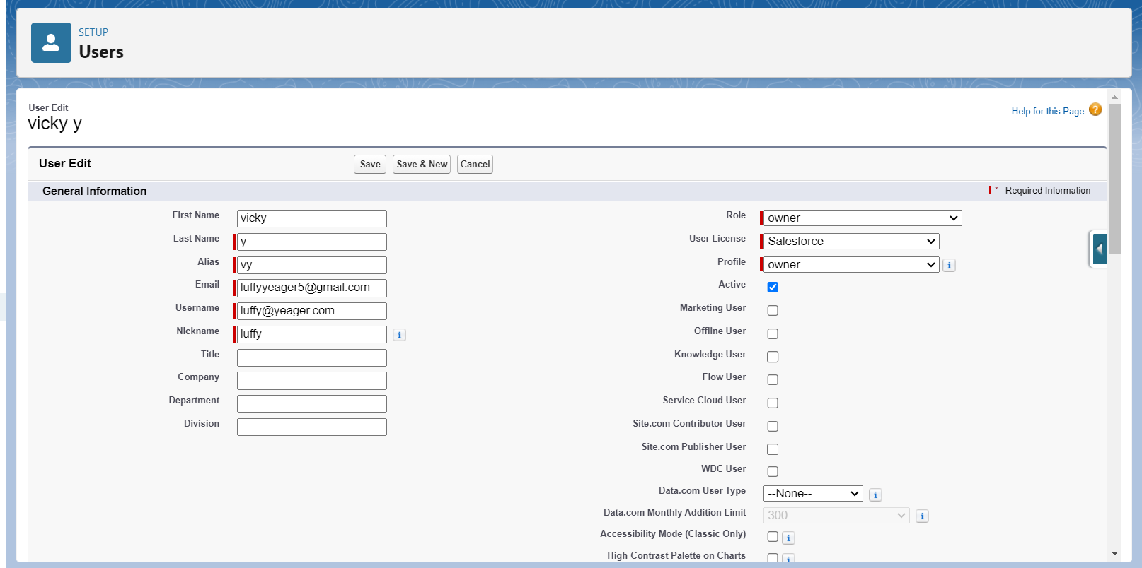

**10.2 Creating Agent Users**

1. **Access User Setup**:
   * Navigate to the users section in Salesforce setup.
2. **New User Details**:
   * Fill in the required fields with the user's details.
   * Assign the role of "Agent".
   * Set the user license to "Salesforce Platform."
   * Assign the profile of "Agent".
3. **Save** 
   * Save the user details.

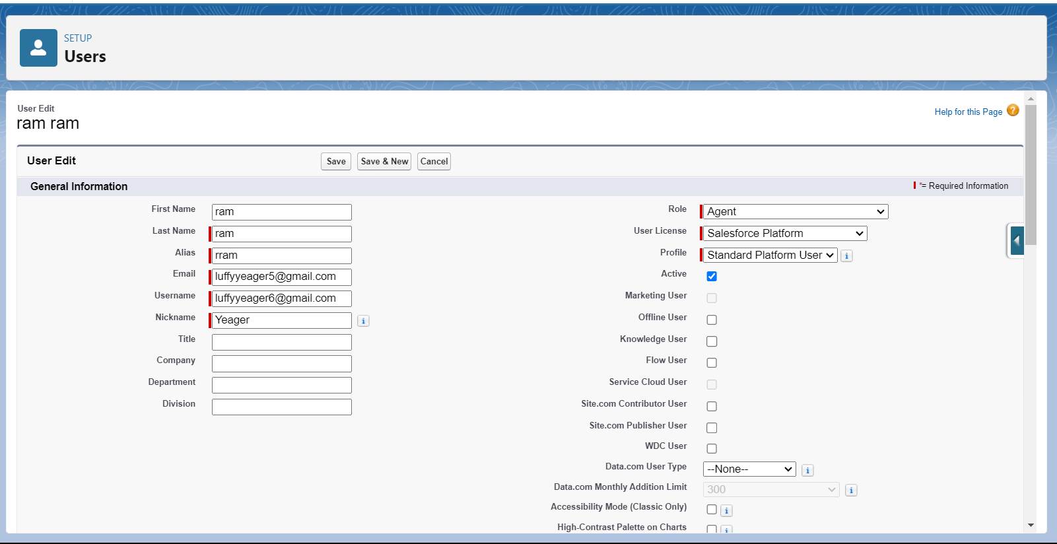

**Task 11**

**Flows**

**Creating the Flow**

1. **Initiate Flow Creation**:
   * Access the Flow setup page and start a new Record-Triggered Flow.
2. **Configure Flow Trigger**:
   * Select "Laptop Booking" as the object.
   * Set the flow to trigger when a record is created or updated.
   * Choose "Actions and Related Records" to optimize the flow.
3. **Add Update Records Element**:
   * Label: Field should be Update
   * Enter the Outcome Details Label: dell

* Resource: Select Record.Laptop booking__c.
* Operator: Select Equals.
* Value: Select dell
* Add the same outcome order to acer, hp, mac.
* Click done.
  + Select select the Outcome ‘+’Details Label: dell core i3
    - * Resource: Select Record.processor.
      * Operator: Select Equals.
      * Value: Select core i3
      * Add the same outcome order to i5 and i7.
      * Click done.
  + Select select the Outcome ‘+’Details Label: months selected and enter outcome details label dell1(i3)
    - * Resource: Select Record.months
      * Operator: Select Equals.
      * Value: 1
      * Add the same outcome order to 2,3,4 and 5 months.
      * Click done.
  + After dell 1(i3) select ‘+’ select update records. Enter the details
    - * Label: one month dell i3 rate
      * Field: Amount__c,
      * Value: for dell1(i3) – 1000, dell2(i3) – 2000, dell3(i3) – 3000, dell4(i3) – 4000.
      * Click done.
  + Repeat the above process for acer, hp and mac with all processors, months and different suitable prices
  + Prices
    - * Dell i7: 1 month-2000, 2 months- 4000…
      * Acer i3: 1 month-900, 2 months- 1800…
      * Hp i5: 1 month- 1700, 2 months-3400…
      * Mac: 1 month- 1700, 2 months-3400…
      * Click done.
  + Click on save.
    - * Label: Laptop distributions
  + Save the flow and activate it.

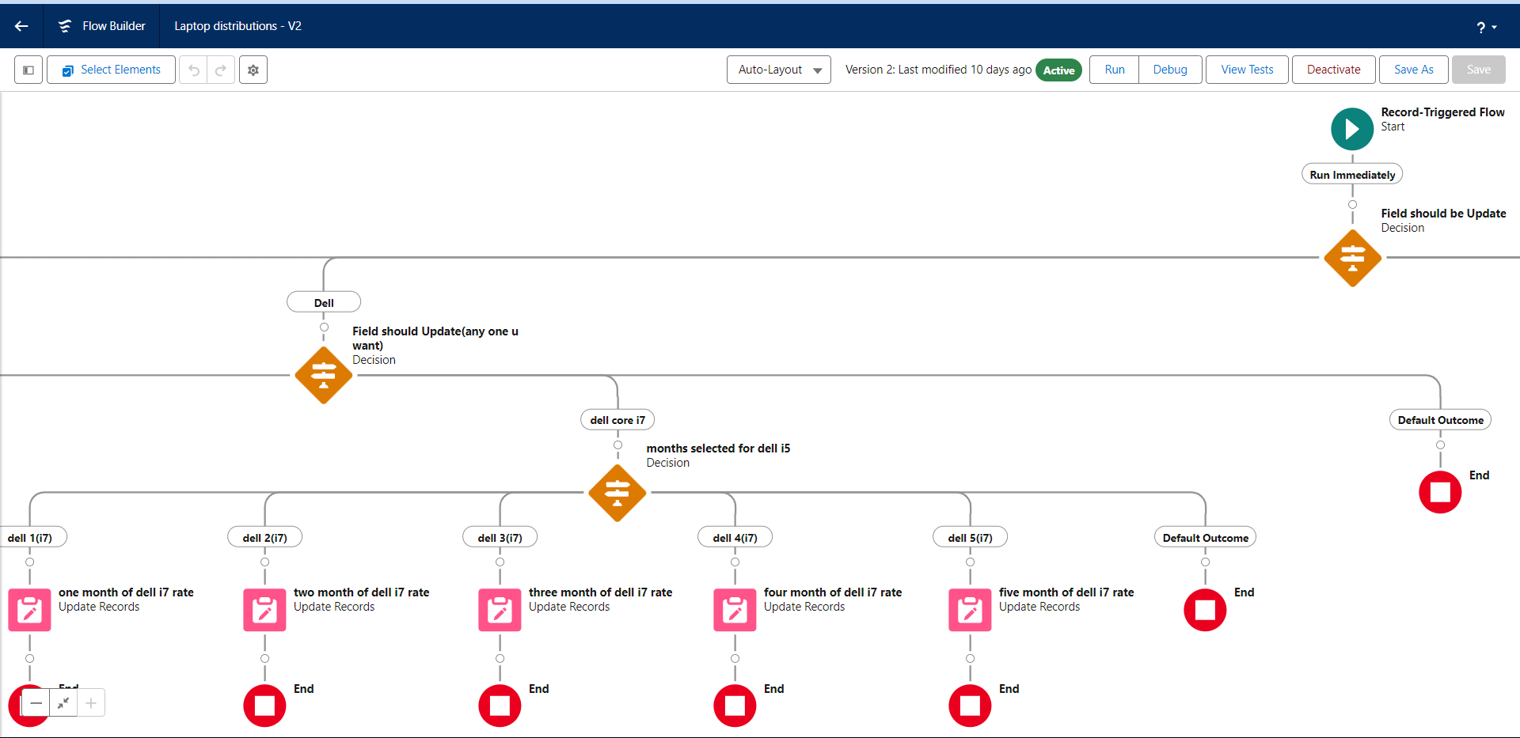

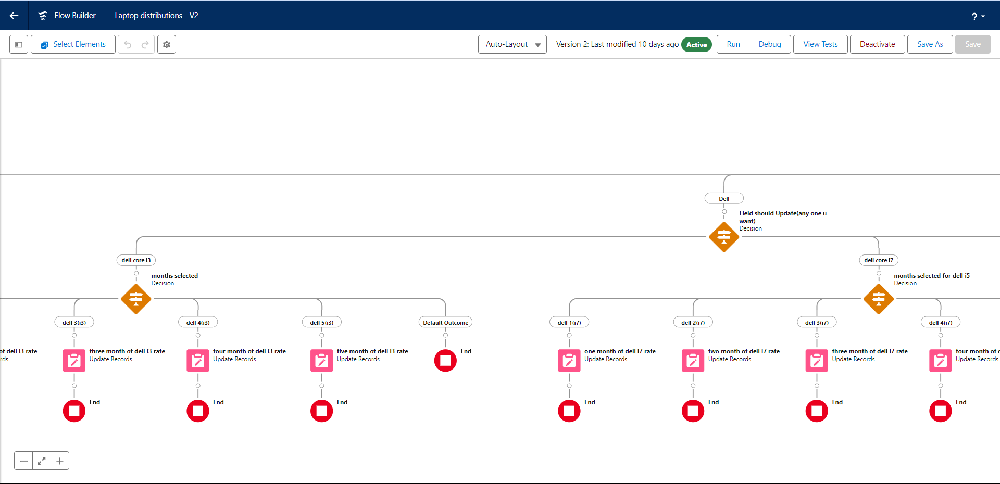

**Task 12**

**Apex Triggers**

**12.1 Apex Handler: LaptopBookingHandler**

**Purpose**: The sendEmailNotification method sends personalized email notifications to customers based on their laptop booking details.

**Class Definition**:

* **Class Name**: LaptopBookingHandler.
* **Method**: sendEmailNotification.
* **Parameters** List<Laptop_Bookings__c>– A list of `Laptop_Bookings__c` records containing customer email, name, and booking details for email notifications.

**Functionality**:

* Loop Through Records:
  + The method iterates over each Laptop_Bookings__c record in the lapList.
* Create and Configure Email Message:
  + For each record, the method creates a new Messaging.SingleEmailMessage object to represent the email message.
  + The setToAddresses method is used to set the recipient's email address (lap.Email__c).
  + The setSubject method sets the email subject to "Welcome to our company."
  + The email body is constructed dynamically using the customer's name (lap.Name) and other booking details, including the laptop amount (lap.Amount__c), processor type (lap.Processor__c), and laptop brand (lap.Laptop_Brand__c).

**Trigger: LaptopBooking on Laptop_Bookings__c**

**Purpose**: The trigger sends email notifications after a `Laptop_Bookings__c` record is inserted or updated.

**Trigger Definition**:

* **Trigger Name**: LaptopBooking
* **sObject**: Laptop_Booking_c
* **Events**: after insert, after update

**Trigger Logic**:

* The trigger checks if records are being inserted or updated.
* It calls the LaptopBookingHandler.sendEmailNotification() method, passing the list of new or updated Laptop_Bookings__c records to send email notifications based on the record details.

**Code:**

trigger LaptopBooking on Laptop_Bookings__c (before insert)

{

if(trigger.isAfter && ( trigger.isInsert || trigger.isupdate))

{

LaptopBookingHandler.sendEmailNotification(trigger.new);

}

}

**Task 13**

**Reports**

**13.1 Creating a Report**

1. **Objective**: Generate a detailed report based on the report type “consumer with Laptop Bookings and Billing Process”.
2. **Preparation**:
   * Ensure to create at least 5 records for each object to ensure comprehensive data representation.
3. **Process**:
   * Access the Reports tab and click on consumer with Laptop Bookings and Billing Process in report type.
   * Start the report builder and configure the fields:
     + **Columns**: consumer Name, Billing Process Name, Laptop Booking Brand, No.of Laptops, months, Amount.
     + **Group Rows**: Payment mode, consumer_name.
   * Save the report with the name **"Report by payment mode "**, ensuring the unique name is auto-populated and the report is saved in the **"Private Reports"**.

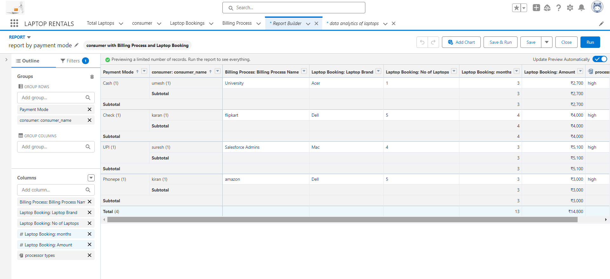

**13.2 Sharing Report to owner**

* + Click edit in the report and click subscribe.
  + Select the desired frequency(everyday), time, select another person radio button.
  + Then save it . Now the report is shared to the recipient email everyday at selected time.

**Task 14**

**Dashboards**

**14.1 Creating a Dashboard Folder**

1. **Objective**: Organize dashboards by creating a specific folder.
2. **Process**:
   * Navigate to the **Dashboards** tab via the app launcher.
   * Click **New Folder** and name it **"total rent amount"**. The unique name is auto-generated.
   * Save the folder to group and manage related dashboards efficiently.

**14.2 Creating a Dashboard**

1. **Objective**: Build a dashboard to visualize data and insights.
2. **Process**:
   * Access the **Dashboards** tab and click **New Dashboard**.
   * Enter a name for the dashboard and select the **"total rent amount"** folder created earlier.
   * Click **Create** to start building the dashboard.
   * Add a new component by selecting **Add Component**.
   * Choose a report to base the dashboard on, and select a **dark component** for visualization.
   * Customize the chart theme as desired.
   * Click **Add** to include the component in the dashboard, then click **Save** and **Done.**

